**UBND TỈNH LÂM ĐỒNG**

**TRƯỜNG CAO ĐẲNG ĐÀ LẠT**

**GIÁO TRÌNH**

**MÔ ĐUN: NGOẠI NGỮ CHUYÊN NGÀNH**

**NGÀNH/: CÔNG NGHỆ SINH HỌC**

**TRÌNH ĐỘ: CAO ĐẲNG VÀ TRUNG CẤP**

*Ban hành kèm theo Quyết định số: /QĐ-... ngày ………tháng.... năm……  
...........……… của …………………………………..*

**Lâm Đồng, năm 2017**

**TUYÊN BỐ BẢN QUYỀN**

Tài liệu này thuộc loại sách giáo trình nên các nguồn thông tin có thể được phép dùng nguyên bản hoặc trích dùng cho các mục đích về đào tạo và tham khảo.

Mọi mục đích khác mang tính lệch lạc hoặc sử dụng với mục đích kinh doanh thiếu lành mạnh sẽ bị nghiêm cấm.

**LỜI GIỚI THIỆU**

Giáo trình ngoại ngữ chuyên ngành được biên soạn cho trình độ cao đẳng và trung cấp CNSH hiện đang được đào tạo tại Khoa Nông nghiệp và sinh học ứng dụng Trường Cao đẳng Đà Lạt

Giáo trình được biên soạn căn cứ trên chương trình khung mô đun phương pháp thí nghiệm và xử lý số liệu trong CNSH

Nguồn tài liệu tham khảo dựa trên nhiều tác giả và các biên soạn giáo trình của đồng nghiệp tại Khoa

Lâm Đồng ngày 10 tháng 10 năm 2018

Tham gia biên soạn

1. Chủ biên: Nguyễn Lâm Thiên Thanh

**GIÁO TRÌNH MÔ ĐUN**

**Tên mô đun:** Ngoại ngữ chuyên ngành

**Mã mô đun:** MH23

**Vị trí, tính chất của môn học:**

1. Vị trí: Môn học Ngoại ngữ chuyên ngành là môn học cơ sơ trong danh mục các môn học, mô đun bắt buộc đào tạo trình độ Cao đẳng Công nghệ sinh học.

2. Tính chất: Môn học Ngoại ngữ chuyên ngành mang tính tích hợp giữa lý thuyết và bài tập, thực hành.

**Mục tiêu môn học:**

Học xong mô đun này người học có khả năng:

1. Về kiến thức:

- Trình bày được một số căn bản lượng từ vựng Anh văn chuyên ngành về kỹ thuật Công nghệ sinh học

2. Về kỹ năng:

- Vận dụng kiến thức để đọc và dịch tài liệu chuyên ngành

- Viết báo cáo chuyên ngành

3. Về năng lực tự chủ và trách nhiệm:

- Sinh viên có khả năng làm việc theo nhóm, có khả năng ra quyết định khi làm việc với nhóm, tham mưu với người quản lý và tự chịu trách nhiệm về các quyết định của mình

- Có khả năng tự nghiên cứu, tham khảo tài liệu có liên quan đến mô đun.

- Có khả năng tìm hiểu tài liệu để làm bài thuyết trình theo yêu cầu của giáo viên.

- Có khả năng vận dụng các kiến thức liên quan vào các môn học tiếp theo.

- Có ý thức, động cơ học tập chủ động, đúng đắn, tự rèn luyện tác phong làm việc công nghiệp, khoa học và tuân thủ các quy định hiện hành

**Nội dung mô đun**

Introduction

1. Aims of the course

The aim of this book is to help students of agriculture develop the four language skills and the ability of using the language knowledge in their communication about their specialist subject as well. The book covers the four skills of listening7 speaking, reading and writing, as well as improving pronunciation and building vocabulary. Particular emphasis is placed on reading. The primaty goal of the course is to provide grammartical knowledge, some technical terms and words belonging to the catering field, that is to improve students’ ability of using the language according to the professional situations, purpose and role of the participants. Moreover with given terms and vocabulary students can read references, self teach to enlarge knowledge and upgrade specialities.

1. Course length

The course contains ISO classes in the one last semesters in the college. There are 6 topic, 72 practical classes and 5 tests for the whole course.

1. The content of the course

The book is devided into 6 main units and 1 review units. Each main unit focuses on a topic related to a particular professional situation and follows the same teaching sequence.

* 1. Structure of a main unit

Presentation includes suggested questions aiming to provide useful information involved in the topic given in the unit and to develop vocabulary and speaking skill as well.

Dialogue introduces the new grammar of each unit in a communicative context and presents functional and conversational expressions

Language Study The new grammar of each unit is presented and is followed by practice activities. Different kinds of exercises for speaking drills such as pairwork, groupwork, or role-play and for grammatical drill provide more opportunity for student practice of the new language items that have just been presented and increase the opportunity for individual student practice.

Vocabulary developes students’ vocabulary through a variety of interesting tasks, such as word map and collocation exercises. Vocabulary activities are usually followed by written or oral practice that helps students understand how to use the vocabulary in context.

Pronunciation These exercises focus on important features of spoken English, including stress, rhythm, intonation, reduction, blending.

Listening the listening activities devolope a wide variety of listening skills, including listening for gist, listening for details and inferring meaning from context. Charts or graphics are often accompanied with these task-base exercises to lend support to students.

Speaking teaches students how to present an issue. Speaking tasks involved the use of the new structures and words given in the unit and concentrate on the topic of the unit.

Reading the reading has two parts: a text and introduction of some dishes. The Readings develop a variety of reading skills, including reading for details, skimming, scanning and making inferences. Sometimes included are pre-reading and post-reading questions in which the topic of the reading is used as a springboard to discussion.

Writing the writing exercises include practical writing tasks that extent and reinforce the teaching points in the unit and help develop students’ writing skills.

* 1. Review units

The review units help students consolidate the students’ knowledge learned from four previous units with a variety of practical exercises.

Keys, wordlist and appendix are at the back of the book as the reference for teachers and students.

1. The method of study

English for students and teaches of agriculture how to use English for very popular professional situations and will certainly provide students with useful language. In addition,students have the opportunity to personalize the language they learn, make use of their own language and experiences and express their ideas and opinions. In order to learn the most effectively, students must be hard-working, active and try to read more references as well as to memorize vocabulary. Outside the classroom practice is also a good method learning

1. **VOCABULARY SKILLS**

# Recognizing the Structure of Words

*Khi bạn không có chút manh mối nào để hiểu được ý nghĩa của từ ngữ, hãy cắt nó thành những thành phần nhỏ. Phần đầu, phần giữa, phần cuối của một từ được gọi, lần luợt là, tiếp đầu ngữ (prefix), từ gốc (root) và tiếp vĩ ngữ (suffix). Học thuộc nghĩa của các tiếp đầu ngữ, từ gốc và tiếp vĩ ngữ thông thường sẽ giúp bạn có cơ sở để phân tích hàng ngàn từ tiếng Anh.*

|  |  |  |  |
| --- | --- | --- | --- |
| **COMMON PREFIX** |  | | |
| **Prefix** | **Meaning** | **Sample word** | **Vietnamese** |
| bi, bin, du | two | bilingual | song ngữ |
| centi | hundred | centigrade | bách phân |
| deci, dec | ten | decimal | thập phân |
| equi | equal | equilibrate | cân bằng |
| micro | small | microorganism | vi sinh vật |
| milli | thousand | milligram | 1/1000 gram |
| mono, mon | one | monosexual | đơn tính |
| multi | many | multivitamin | nhiều vitamin |
| poly | many | polyembryonic | có nhiều phôi |
| semi, demi, hemi | half | semicolon | dấu chấm phẩy |
| tri | three | triangle | tam giác |
| uni | one | uniform | đồng phục |
| **Prefix** | **Meaning** | **Sample word** | **Vietnamese** |
| **Prefixes meaning ‘not’ (negative)** | | | |
| a | not, laking in | atypical | không điển hình |
| anti | against | antibiotic | kháng sinh |
| contra | against, opposite | contraception | ngừa thai |
| dis | the opposite of, not | disadvantage | bất lợi |
| in | not, without | independent | độc lập |
| ir | not, without | irreducible | không giảm được |
| im | not, without | impossible | không thể được |
| il | not, without | illogical | vô lý |
| mis | wrongly | misinform | báo tin sai |

|  |  |  |  |
| --- | --- | --- | --- |
| non un  pseudo  **Prefix** | not not  false, imitation  **Meaning** | non-smoker unfair pseudonym  **Sample word** | người không hút gian lận  bút danh, biệt hiệu  **Vietnamese** |
| **Prefixes giving direction, location, or placement** | | | |
| circum | around | circumfluent | chảy quanh |
| com | with, together | compile | biên soạn |
| col | with, together | collaborate | hợp tác |
| con | with, together | conductor | người chỉ huy |
| de | reverse, away, from | defrost | rã đông |
| ex | outside, former | exclude | loại trừ |
| extra | outside, former | extracellular | ngoại bào |
| hyper | excessive, extremely | hyperplasia | tăng sản |
| inter | between, among | interaction | tương tác |
| intra | inside, into, in | intravenous | (tiêm) tĩnh mạch |
| intro | inside, into, in | introversion | tụt vào trong |
| post | after | post-graduate | sau đại học |
| pre | before | prematuration | trước tt., đẻ sớm |
| re | again, back | rebuild | xây dựng lại |
| retro | backward, behind | retrospective | xem lại quá khứ |
| sub | beneath, lower in | subway | đường ngầm |
| super | extra, over | supercentrifuge | siêu li tâm |
| tele | linking, distance | telecontrol | điều khiển từ xa |
| trans | to a changed state | transsexual | chuyển giới tính |
| **ROOT** |  |  |  |
| **Root** | **Meaning** | **Sample word** | **Vietnamese** |
| aud, audit, audio | of hearing, of sound | audible | nghe rõ |
| aster, astro | of the start, outer space | astronaut | phi hành gia |
| bio | of life, living organism | biology | sinh học |
| cap | take, seize | capture | bắt, thu hút |
| chron(o) | of time | chronologically | theo thứ tự thời gian |
| corp | body | corpse | xác chết |

|  |  |  |  |
| --- | --- | --- | --- |
| cred | believe | incredible | không tin nổi |
| dict, dic | tell, say, speak | dictionary | từ điển |
| duc, duct | lead | introduce | giới thiệu |
| fact, fac | make, do | factory | xí nghiệp, nhà máy |
| graph | st. written down | telegraph | điện báo |
| geo | earth | geographical | liên quan địa lí |
| log, logo, logy | branch of learning | psychology | tâm lí học |
| mit, miss | send | mission | nhiệm vụ |
| mort, mor | die, death | immortal | bất diệt |
| path | feeling | sympathy | thông cảm |
| phone | produce sound | telephone | điện thoại |
| port | carry, take | transport | vận chuyển |
| scope | means of observing | microscope | kính hiển vi |
| scrib, script | write | manuscript | bản thảo |
| sen, sent | feel | insensitive | không nhạy cảm |
| spec, spic | look, see | spectroscope | kính quang phổ |
| tend, tent, tens | strecht, strain | hypertension | tăng huyết áp |
| terr, terre | land, earth | territory | lãnh thổ |
| theo | of God | theology | thần học |
| ven, vent | come together | convention | qui ước |
| vert, vers | turn | invert | đảo ngược |
| vis, vid | see | visible | có thể thấy được |
| voc | voice, call | vocalise | phát âm |
| **SUFFIXES** |  |  |  |
| **Suffix** | **Added → to form** | **Meaning** | **Sample word** |
| **Suffixes that refer to a state, condition or quality** | | | |
| -able | verbs → adjectives | able, worthy | readable |
| - ible | verbs → adjectives | to be V-ed | forcible |
| - ance | verbs → nouns | state, quality | assistance |
| -ation | verbs → nouns | state, action | exploration |
| - ment | verbs → nouns | state, action | amazement |
| -al | verbs → nouns | action | refusal |
| -ness | adjective → nouns | state, quality | happiness |

|  |  |  |  |
| --- | --- | --- | --- |
| -ity | adjective → nouns | state, quality | sanity |
| -ful | nouns→ adjectives | amount | mouthful |
| -en | adjective → verbs | causative | weaken |
| - ful | nouns→ adjectives | having, giving | helpful |
| -ly | adjective → adverbs | in a…manner | happily |
| - ive | verbs → adjectives | manner | attractive |
| - ous | nouns→ adjectives | manner | virtuous |
| - ty | adjective → nouns | quality | loyalty |
| -y | nouns→ adjectives | like, coverred with | creamy |

### Suffixes that mean ‘one who’

|  |  |  |  |
| --- | --- | --- | --- |
| -eer | nouns→ pronouns | occupation | engineer |
| -er | nouns→ nouns | inhabitant of X | Londoner |
| -er, or | verbs → nouns | instrumental | reciever |
| -ist | nouns→ adjectives | member of party | socialist |
| -ant | verbs → nouns | agentive | disinfectant |

**Suffixes that refer to ‘status or domain’**

|  |  |  |  |  |
| --- | --- | --- | --- | --- |
| -hood | nouns→ | nouns | status | childhood |
| -ship | nouns→ | nouns | status | friendship |
| -dom | nouns→ | nouns | domain, condition | kingdom |
| -(e)ry | nouns→ | nouns | behaviour, place | slavery, refinery |

* 1. **Compound words**

*Nhiều tác giả thường sử dụng từ ghép để làm cho những diễn đạt của họ trở nên xúc tích hơn. Có 2 loại từ ghép: danh từ ghép và tính từ ghép. Hiểu biết về các lọai từ ghép cũng như kỹ thuật giải thích những lọai từ này sẽ giúp bạn hiểu được tài liệu bạn đang đọc hiệu quả hơn.* **Compound nouns**

Compound nouns are often used in scientific and technical writing. The most complicated compound nouns of all occur in newspaper and technical advertisement, because in both cases, the writers need to put as much as information into as few words as possible. These long compound nouns sometimes difficult to understand. However, they are not as difficult as they look, if you follow this principle: **begin at the end and then work forward.**

**Examples:** sun glasses kính mát

contact lens kính sát tròng

greenhouse effect hiệu ứng nhà kính

heart attack đau tim

blood donor người cho máu

death penalty án tử hình

food poisoning ngộ độc thực phẩm

hay fever dị ứng phấn hoa

birth control kiểm soát sinh đẻ

### Compound adjectives

Some principles of making compound adjectives:

### Noun- V-ed + noun

Example: a wind-driven pump một cái bơm chạy bằng sức gió

### Adv/adj-V-ed + noun

Example: a badly-designed bridge một cây cầu được thiết kế tệ

### Noun- V-ing + noun

Example: a rubber-producing country một quốc gia sản xuất cao su

### Adv/adj-V-ing + noun

Example: a fast flowing river một dòng sông chảy xiết

### Adj-noun-ed + noun

Example: a long legged girl một cô gái chân dài

### Noun- adj + noun

Example: an oil free moiturizer mỹ phẩm làm ẩm da không có dầu

### Interesting compound adjectives

a broken-down bus (it doesn’t work) a hard-up student (poor)

worn-out shoes (can’e be worn anymore)

a drive-in movie (you wacht from your car) a run down car (in poor condition)

cast-off clothes (no longer wanted by the owner) well-off bankers (wealthy)

a burnt-out car (nothing left in it after a fire)

### Compound adjectives describing a person’s character

absent-minded (forgetful) easy-going (relaxed) good-tempered (cheerful) warm-hearted (kind) quick witted (intelligent)

big-headed (proud of oneself) two-faced (hypocritical)

self-centered (egotistical) stuck-up (snobbish)

### Other common compound adjectives

first-class; first lady; first-born; second-class; last-minute duty-free, interest-free; sugar-free, fat-free

so-called; world famous; part-time; time-consuming…

# Context clues

*Một trong những cách thực tế và dễ nhất để hiểu được nghĩa của những từ chưa biết là học thật kỹ lưỡng xem từ này đã được dùng như thế nào trong câu, đoạn văn tìm thấy. Ngữ cảnh thường chứa đựng nhiều manh mối giúp bạn đoán được từ chưa biết đó.*

There are four basic types of context clues:

**Definition:** A brief definition or a synonym of an unknown word may be included in the sentence in which the word is used.

**Example- illustration**: Words and ideas may be explained by giving specific, concrete example of them.

**Contrast:** The meaning of an unknown word can sometimes be determined from a word or phrase in the context that has the opposite meaning.

**Logic of the passage:** The meaning of an unknown word may be determined through reasoning or applying logic to the content of the sentence or paragraph.

# Using a dictionary

*Một quyển từ điển không chỉ cung cấp nghĩa của từ mà có thể cho bạn biết nhiều thông tin hơn như là cách phát âm, vị trí nhấn, từ đồng nghĩa, từ trái nghĩa, cách dùng, loại từ và ví dụ cụ thể trong nhiều văn cảnh. Hầu hết các từ có hơn 1 nghĩa. Do đó, khi tìm nghĩa của từ, hãy cố gắng tìm ra nghĩa sát/ phù hợp nhất với văn cảnh.*

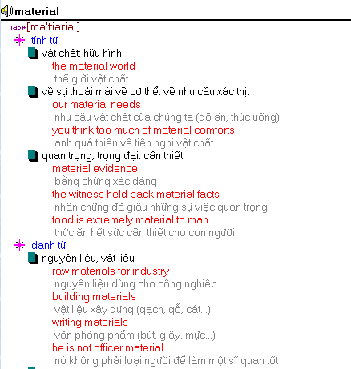

# Understanding sentence patterns

*Một câu thể hiện ít nhất 1 ý chính, bao gồm một chủ ngữ và vị ngữ. Phần còn lại của câu chứa đựng các thông tin nhằm giải thích, làm sáng tỏ hoặc giới hạn ý chính. Mức độ quan trọng của các từ trong câu không bằng nhau. Khi đọc câu, hãy định vị ý chính và xác định những phần còn lại của câu ảnh hưởng thế nào đến ý chính đó.*

*Hai hoặc nhiều ý hoàn chỉnh có thể được kết hợp trong một câu duy nhất. Điều này nhằm nhấn mạnh hoặc làm rõ mối liên hệ giữa các ý. Một số câu có chứa 1 ý chính và 1 ý liên hệ ít quan trọng hơn ý chính. Hãy đảm bảo là bạn nhận biết được các ý liên hệ với nhau*

*ra sao. Chú ý đến các từ nối. Thường thường, ý phụ giải thích cho ý chính bằng cách mô tả, thể hiện nguyên nhân, nêu lí do, miêu tả diều kiện, hoặc hiển thị mối liên hệ thời gian.*

*Bí quyết để đọc một câu phức tạp là tách nó thành những phần nhỏ. Nhận diện ý chính và các ý khác rồi xem xét xem các phần bổ nghĩa làm thay đổi ý nghĩa ra sao. Kế đến, diễn giải chúng theo ngôn ngữ của chính bạn. Kiểm tra nghĩa của những từ không quen, nếu cần.*

### The subject – the predicate

The simple subject, usually a noun, identifies the person or thing the sentence is about. The main part of the predicate is a verb which tells what the person or thing is doing or has done. Usually a sentence contains additional information about the subject and/or the predicate.

Example:

#### Subject Predicate Additional information about the predicate

The liquid rises in the test tube.

### Locating details

After you have identified the key idea, the next step in understanding a sentence is to see how the details affect its meaning. Most details either add to or change the meaning of the key idea. Usually they answer such questions about the subject or predicate as WHAT, WHERE, WHICH, WHEN, HOW or WHY.

Example:

|  |  |  |  |
| --- | --- | --- | --- |
|  | WHAT | WHERE | WHEN |
| Sam *drove* | his car | to Toronto | last week |

### Sentence that combine ideas

Here is a list of connecting words and what they tell you about the relationship between the ideas.

#### Connecting words meaning signals

and links similar and equally important idea

but, yet connects opposite ideas or change in thought

for, so indicates reasons or shows that one thing is causing another

or, nor suggests choice or options exist

before, after indicates time

because gives reasons

if, unless explains conditions or circumstances although, however qualifies, explains, describes circumstances

### Reading complicated sentences

***Step 1. Locate the key idea***(s) by identifying the subject and the predicate. Establish what the sentence is about and what action is occurring. Be alert for two or more subject and/ or verbs. Many complicated sentences have more than one key idea.

***Step 2. Study the modifier****.* Identify how each remaining piece of the sentence changes its meaning. Does it describe, give additional information about the subject, object or verb? Does it tell when, why, how or where the action occurred?

***Step 3. Paraphrase****.* Express the sentence’s basic meaning in your own words without referring to the sentence. Split it into two or more basic sentences, if necessary. This step provides the real test of whether you actually understand the sentence.

***Step 4. Check vocabulary***. If step 3 fails, then difficult or technical vocabulary may be interfering with your comprehension. Use techniques learned in lesson 1.4.

# Understanding paragraphs

*Một đoạn văn là một nhóm các câu có liên hệ với nhau về một chủ đề. Đoạn văn chứa đựng 3 phần thiết yếu:*

* *Chủ đề Một điều được nói đến trong toàn bộ đoạn văn.*
* *Ý chính Ý quan trọng nhất mà người viết muốn người đọc biết về chủ đề đó.*
* *Chi tiết Sự kiện và ý kiến nhằm chứng minh hoặc giải thích ý chính.*

*Một đoạn văn, do đó, cung cấp những lí giải và chứng minh cho một chủ đề cụ thể. Câu thể hiện ý chính gọi là câu chủ đề. Trong hầu hết các đoạn văn thường có câu chủ đề. Một câu chủ đề có thể nằm ở bất kì nơi nào trong đoạn văn nhưng thông thuờng nhất là ở đầu, cuối, giữa hoặc cả đầu và cuối.*

*Có 5 lọai chi tiết thường dùng để phục vụ cho ý chính: ví dụ, sự kiện và thống kê, nguyên nhân, mô tả, và các bước thực hiện hoặc tiến trình.*

# Scanning

*Đọc lướt là một phương pháp đọc có chọn lọc khi tìm kiếm một sự kiện cụ thể hoặc để trả lời câu hỏi. Bạn có bao giờ nghĩ đến những tính huống mà bạn không cần đọc hết tất cả các từ trong một trang in không? Lấy ví dụ việc tra cứu danh bạ điện thoại. Bạn có bao giờ đọc hết các trang trong quyển danh bạ đó không? Câu trả lời hiển nhiên là mỗi lần tra cứu, bạn chỉ*

*đọc có chọn lựa, lấy những thông tin cần và bỏ qua những thứ khác. Trong thực tế, có rất nhiều tình huống khác tương tự.*

#### Kỹ thuật đọc lướt:

1. *Nhớ trong đầu về thông tin đặc biệt mà bạn đang tìm*
2. *Cố gắng đoánn xem câu trả lời sẽ xuất hiện ở đâu và điều gì là manh mối bạn có thể sử dụng để xác định vị trí câu trả lời*
3. *Di chuyển con mắt nhìn của bạn một cách có hệ thống trên trang giấy có thông tin theo kiểu mũi tên hoặc zigzag.*
4. *Khi bạn gặp sự kiện mà bạn đang tìm kiếm, bạn sẽ thấy những từ và ngữ nổi bật.*
5. *Đọc câu văn có thông tin trong đó để xác nhận lại đó là thông tin đúng.*

# Prereading techniques

*Đọc lướt (skimming) là một kỹ thuật hữu dụng khi bạn muốn đọc có chọn lọc, chỉ những ý chính và lướt sơ qua phần dữ liệu còn lại. Có 3 dạng đọc lướt với mục đích khác nhau tùy theo người đọc.*

#### There are three types of skimming:

* + - Prereading skimming: in this form, you are planning to read the entire article or chapter and you are using this technique as a mean of getting ready to read.
    - Skim-reading: this refers to situations in which skimming is the only coverage your plan to give the material.
    - Review skimming: this assumes you have already read the material and are going back over it as a mean of study and review.

**How to skim**

When you skim, try to

1. find only the most important ideas in the material.
2. notice how they are organized. To do this, look only at the parts that state these important ideas and skip the rest. It should take only a few minutes to skim a text book chapter (10-15 pages) and even fewer to skim an article (3-5 pages). The following is a step-by step procedure to follow in skimming for the main idea.
   1. Read **the title**. If it is an article, check if there is a subtitle. This subtitle will tell how the writer approaches the subject.
   2. Read **the introduction**. If it is long, read only the first paragraph. Read the first sentence of the other paragraphs. Usually this sentence will be a statement of the main idea of each paragraph.
   3. Read any **headings and subheadings**. Headings, like titles, serve as label and identify the topic of the material. They also form and outline of the main topic covered in the material.
   4. Notice any **pictures, charts, or graphs** included to emphasize important ideas, or concepts.
   5. Read **the summary or last paragraph**. This will give a condensed view of the passage and help you to identify key ideas.

# Activity: Biotechnology - General Information

### Biotechnology – definition

Biotechnology is the application of knowledge of living systems to use those systems or their components for industrial purposes. The word “biotechnology” was first used by the Hungarian agricultural economist Karoly Ereky in 1919, to mean “all lines of work by which products are produced from raw materials with the aid of living organisms.” The definition has been broadened slightly to include producing things with the aid of materials from living organisms (such as enzymes) and some raw materials that are produced from living organisms themselves (such as alginates or biomass), and narrowed to focus on new technologies, rather than traditional production processes.

So biotechnology is the practical **combination of science and technology** to make use of our **knowledge of living systems for practical application**. This includes a wide variety of applied biological science, but also includes aspects of chemistry, chemical technology, engineering, and specialist disciplines in specific industries such as pharmaceutical, environment treatment or agricultural industries. There are about 1300 biotechnology companies in the United State, with 260 being public companies (whose shares are traded on the stock markets), and a total revenue of about $25 billion. There are around the same number in Europe, those mostly in the UK reflecting the breadth of ground covered by the industry.

Note also that biotechnology is not the same as “applied molecular biology.” Genes, DNA and all the sciences associated with them get a lot of press nowadays, but equally important for the end users of biotechnology are food, beer, vitamins, and other products through the wide range of technologies.

### Sub-fields of biotechnology

There are a number of technical terms for sub-fields of biotechnology.

**Red biotechnology** is biotechnology applied to medical processes. Some examples are the designing of organisms to produce antibiotics, and the engineering of genetic cures to cure diseases through genomic manipulation.

**White biotechnology**, also known as **grey biotechnology**, is biotechnology applied to industrial processes. An example is the designing of an organism to produce a useful chemical. White biotechnology tends to consume less in resources than traditional processes when used to produce industrial goods.

**Green biotechnology** is biotechnology applied to agricultural processes. An example is the designing of an organism to grow under specific environmental conditions or in the presence (or absence) of certain agricultural chemicals. One hope is that green biotechnology might produce more environmentally friendly solutions than traditional industrial agriculture. An example of this is the engineering of a plant to express a pesticide, thereby eliminating the need for external application of pesticides. Whether or not green biotechnology products such as this are ultimately more environmentally friendly is a topic of considerable debate.

**Bioinformatics** is an interdisciplinary field which addresses biological problems using computational techniques. The field is also often referred to as computational biology. It plays a key role in various areas like functional genomics, structural genomics, and proteomics amongst others, and forms a key component in biotechnology and pharmaceutical sector.

The term **blue biotechnology** has also been used to describe the marine and aquatic applications of biotechnology, but its use is relatively rare.

### Biotechnology timeline

* 8000 BC Collecting of seeds for replanting. Evidence that Babylonians, Egyptians and Romans used selective breeding (artificial selection) practices to improve livestock.
* 6000 BC Brewing beer, fermenting wine, baking bread with help of yeast
* 4000 BC Chinese made yogurt and cheese with lactic-acid-producing bacteria
* 1500 Plant collecting around the world
* 1675 Microorganisms discovered (using first microscope)
* 1856 Gregor Mendel discovered the laws of inheritance
* 1919 Karl Ereky, a Hungarian engineer, first used the word biotechnology
* 1953 James D. Watson and Francis Crick describe the structure of DNA
* 1975 Method for producing monoclonal antibody developed by Kohler and Milstein
* 1980 Modern biotech is characterized by recombinant DNA technology. The prokaryote model, *E. coli*, is used to produce insulin and other medicine, in human form (about 5% of diabetics are allergic to animal insulins available before).
* 1980 A viable brewing yeast strain *Saccharomyces cerevisiae* 1026 acts a modifier of the microflora in the rumen of cows and digestive tract of horses
* 1984 Nutrigenomics as applied science in animal nutrition
* 1994 FDA approves of the first GM food from Calgene: "Flavr Savr" tomato
* 2000 Completion of the Human Genome Project

**Some useful websites in biotechnology**

* + - Asia-Pacific Biotech News: <http://www.asiabiotech.com/>
    - Aventis [http://www.aventis.com/main/0,1003,EN-XX-100---,FF.html](http://www.aventis.com/main/0%2C1003%2CEN-XX-100---%2CFF.html)
    - BioJobNet <http://www.biojobnet.com/>
    - Biotechnology at the OECD <http://www.oecd.org/ehs/icgb/>
    - Biotechnology and Food Safety at the OECD [http://www.oecd.org/EN/home/0,,EN-](http://www.oecd.org/EN/home/0%2C%2CEN-) home-32-nodirectorate-no-no-no-32,00.html
    - Biotechnology Japan <http://biotech.nikkeibp.co.jp/BIO.shtml>
    - Biotrack Online [http://www.oecd.org/EN/home/0,,EN-home-528-nodirectorate-no-](http://www.oecd.org/EN/home/0%2C%2CEN-home-528-nodirectorate-no-) no-no-27,FF.html
    - Canadian Biotechnology Strategy <http://strategis.ic.gc.ca/SSG/bh00127e.html>
    - DuPont Biotechnology <http://www.dupont.com/biotech/>
    - Profile - The Biotechnology Industry in Canada <http://www.hrdc-drhc.gc.ca/hrib/hrp-> prh/ssd-des/english/industryprofiles/biotech/index.shtml
    - Monsanto <http://www.monsanto.com/monsanto/default.htm>
    - National Centre for Biotechnology Education – UK <http://www.ncbe.reading.ac.uk/>
    - Novartis <http://www.novartis.com/>
    - The Science Advisory Board <http://www.scienceboard.net/>
    - United States Department of Agriculture (USDA)<http://www.aphis.usda.gov/ppq/biotech/>
    - ABC Science – The Lab <http://www.abc.net.au/science/slab/consconf>
    - First Australian Consensus Conference on Gene Technology and Food<http://www.abc.net.au/science/slab/consconf>
    - Organic Federation of Australia <http://www.ofa.org.au/>
    - Network of Concerned Farmers <http://www.non-gm-farmers.com/index.asp>

### Courses taught in B.Sc. in Biotechnology program

**Courses in basic sciences**

English General physics

Advanced mathematics Biology

General chemistry Organic chemistry

Practices of general physics Practices of general chemistry Practices of general biology Philosophy

Human being and environment Statistics - probability Introduction of computer science Inorganic chemistry

Political economics Physical education General psychology General economics

Vietnamese and word processing

### Courses in biotechnology

Genetics Biochemistry Microbiology Bio-physics

Quantitative Genetics Molecular biology General biotechnology Animal physiology Plant physiology

Enzyme and protein technology Fermentation technology

Plant tissue culture Animal tissue culture Bio-technological lab English in biotechnology General pathology

Genetic engineering

Thermal and mass transfer technology Waste treatment technology

Food inspection

Biostatistics and experimental method Bio-infomatics

Bio-safety

Bio-product laws Environment biotechnology Animal biotechnology Veterinary biotechnology Plant biotechnology Aquaculture biotechnology Undergraduate thesis

### Glossary

antibiotic [,æntibai'ɔtik] kháng sinh

application [,æpli'kei∫n] ứng dụng

aquatic application [ə'kwætik] ứng dụng thủy sinh

biotechnology [,baiətek'nɔlədʒi] công nghệ sinh học

components [kəm'pounənt] thành phần

considerable debate [kən'sidərəbl] nhiều tranh cãi

cure [kjuə] chữa bệnh

eliminate [i'limineit] lọai bỏ, loại trừ environment treatment [in'vaiərənmənt] xử lý môi trường

environmentally friendly solutions [sə'lu:∫n] giải pháp có ích cho môi trường express [iks'pres] thể hiện (tính trạng)

fermentation [,fə:men'tei∫n] lên men

functional genomic ['fʌηk∫ənl] gen chức năng

gene [dʒi:n] gen

genetically modified (GM) product [dʒi'netikəli] sản phẩm biến ñổi di truyền inheritance [in'heritəns] sự thừa kế

interdisciplinary [,intə'disiplinəri] liên quan tới nhiều lĩnh vực, liên ngành

key role [ki:] vai trò then chốt/ chủ yếu

manipulation [mə,nipju'lei∫n] thao tác

marine [mə'ri:n] biển

material [mə'tiəriəl] nguyên liệu

molecular biology [mou'lekjulə] sinh học phân tử

monoclonal antibody ['æntibɔdi] kháng thể ñơn dòng

organism ['ɔ:gənizm] sinh vật

pesticide ['pestisaid] thuốc trừ sâu pharmaceutical industry [,fɑ:mə'sju:tikəl] công nghiệp dược

prokaryote [prəʊ'kæriət] sinh vật chưa có nhân ñiển hình (nhân sơ)

recombination [ri,kəmbi'nei∫n] sự tái tổ hợp, sự kết hợp lại

resource [ri'sɔ:s ; ri'zɔ:s] tài nguyên, nguồn nguyên liệu

selective breeding ['bri:diη] nhân giống có chọn lọc

**Cloning Animals**

Advances in biotechnology have allowed scientists to make genetically identical copies or clones of animals. Duplication of an organism's genome occurs naturally when identical twins are born or when a plant is grown from a cutting of another plant. However, the world really took notice of cloning in 1997 when a group of Scottish researchers announced the birth of Dolly the sheep, which had been cloned using a single cell from an adult sheep. Dolly had only one "parent;" her nuclear genome was exactly like her "mother's" instead of being a combination of two parents. Therefore, Dolly could generally be thought of as her mother's identical twin.

To produce Dolly, scientists took an egg from a sheep and removed its nucleus (which contains the genome or instruction manual), rendering it unable to function or develop. Next, they took a cell with an intact genome from a different adult sheep (Dolly's "mother") and fused it to the sheep egg which lacked a genome. The egg, with its new genome, was stimulated to begin developing into an embryo and was implanted into a surrogate sheep where it grew normally, resulting in the birth of Dolly. Dolly later gave birth to normal lambs.

### Benefits and Risks of Cloning

Researchers have cloned other mammals including cows, goats, pigs, and mice. However, the overall low rate of successful cloning and frequent occurrence of developmental abnormalities in cloned animals demonstrate the need for further research before cloning will be practical

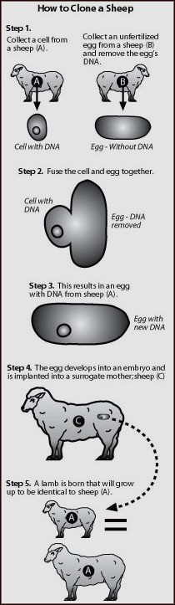.

It has also been reported that cloned animals may exhibit health problems throughout their life. Cloned animals may age prematurely as Dolly was diagnosed with arthritis at a seemingly young age and cloned mice had a shorter than normal life span. Additionally, it was demonstrated that cloned mice were both larger in size and heavier than a control group of non-cloned mice.

If advances in animal cloning technology were to overcome the current obstacles, the most obvious benefit would be the ability of a farmer to have a herd of superior performing animals in one generation. Breeding companies could sell cloned embryos in a manner similar to the way in which semen is currently marketed. A potential drawback of this practice would be the loss of genetic diversity in livestock herds, but this could be avoided by limiting the number of cloned embryos of a given animal that were sold.

It has also been proposed that cloning could be used to increase the population of animals in an endangered species. The mouflon sheep, which is a wild Mediterranean sheep with less than 1000 animals remaining, was successfully cloned. Additionally, scientists are attempting to clone an endangered wild Asian ox, called the guar (the first cloned guar died of an intestinal illness shortly after birth) and possibly the giant Panda. Although possible, a recovering population of cloned animals would be hindered by a lack of genetic diversity and would not address the larger issue of how the animal became endangered.

### Glossary

adult ['ædʌlt] con trưởng thành

announce [ə'nauns] loan báo, thông báo

arthritis [ɑ:'θraitis] chứng viêm khớp

demonstrate ['demənstreit] chứng tỏ, giải thích

diversity [dai'və:siti] tính ña dạng

drawback ['drɔ:bæk] mặt hạn chế, ñiều trở ngại

duplication [,dju:pli'kei∫n] sự nhân ñôi

endanger [in'deindʒə(r)] nguy hiểm, nguy cơ tiệt chủng

fuse [fju:z] nấu chảy, hòa lẫn

hinder ['hində] cản trở

identical [ai'dentikəl] chính, giống hệt

intact [in'tækt] còn nguyên vẹn

obstacle ['ɒbstəkl] trở ngại

potential [pə'ten∫l] tiếm tàng, tiềm năng

render ['rendə] làm cho, trả lại, giao lại

researcher [ri'sə:t∫ə] nhà nghiên cứu

surrogate ['sʌrəgit] người, vật thay thế

twin [twin] sinh ñôi, cặp ñôi

# Reading assay and article

**An assay** is a procedure where a property or concentration of an analyte is measured.

There are numerous types of assays, such as an antigen capture assay, bioassay, competitive protein binding assay, crude oil assay, four-point assay, immunoassay, microbiological assay, stem cell assay, and many others, including concentration assays.

**An article** is a stand-alone section of a larger written work. These nonfictional prose compositions appear in magazines, newspapers, academic journals, the internet, or any other type of publication.

# Activity: “General PCR Protocol”

*Sally A. Green, 2-17-96*

Here in the Maddock Lab, we do 25µl PCR reactions in 0.5mL microfuge tubes. You can do PCR in different size reaction volumes and in smaller tubes as long as they fit in the thermocycler.

### Materials:

template DNA (genomic, plasmid, cosmid, bacterial/yeast colony, etc.) primers (resuspended to a known concentration with sterile TE)

buffer (usually 10X, usually sold with Taq polymerase or you can make your own)

***note:*** *some different buffer receipes follow at the end of this protocol*

MgCl2 (25mM is convenient)

Taq polymerase dNTPs (2mM stock)

***note:*** *a 2mM stock of dNTPs means that the final concentration of each dNTP (dATP, dCTP, dGTP, and dTTP) is 2mM -- NOT that all dNTPs together make 2mM. dNTPs come as 100mM stocks -- thaw and add 10*µ l *of each dNTP to 460*µl *of ddH20 to make 2mM. Store at - 20°C.*

sterile ddH20 gloves

PCR machine

aerosol tips, if desired

*PCR is very sensitive to contamination from outside DNAs. Steps should be taken to reduce the chance for contamination, such as wearing gloves, using aerosol tips (tips with a wad of cotton at the top), and not spitting in the tubes. I don’t use aerosol tips and have dispensed with the gloves -- just be careful. Something that IS important is to assemble your reactions on ice.*

**The final concentrations of reagents in PCR reactions are as follows: buffer:** 1X, usually comes as 10X stock. For 25µl reactions, this means 2.5µl.

**dNTPs:** for most general PCR, you want the final concentration to be 200µM, so a 2mM stock is essentially 10X -- use 2.5µl per reaction.

**primers:** a good place to start with primer concentration is 50pmol of each primer per reaction. If you don’t get your desired product, you can increase to 75pmol or 100pmol. This usually does the trick. I wouldn’t go past 200pmol of primers unless it’s a special protocol that recommends using more.

***note:*** *hints on resuspending primers follow this protocol*

**template:** it’s not usually necessary to be incredibly fastidious about how much template you add to a reaction. You can get product with incredibly small amounts of starting DNA. I usually do a 3mL plasmid prep and use 1/6 of a microliter per PCR reaction. You can use more or less -- it doesn’t seem to matter that much.

**MgCl2:** this is the greatest variable in PCR. The success of a PCR is very dependent on how much magnesium is present in the reaction. For this reason, it is usually advisable to do a magnesium optimization when performing new PCRs. I do my reactions in sets of six, keeping all variables constant except for magnesium. I usually go from 1mM to 6mM MgCl2. Since the stock is 25mM, usually, this means that 1µl of stock equals 1mM MgCl2 in a 25µ l reaction -- it’s convenient.

Given that you’re probably going to do at minimum six PCR reactions with six different magnesium concentrations, and you will have to add several different ingredients, it’s useful to take steps to reduce the number of pipetting steps, which in turn reduces time and change for cross-contamination.

### Glossary

assemble [ə'sembl] tập hợp

convenient [kən'vi:njənt] tiện lợi

dispense [dis'pens] miễn trừ, bỏ qua

fastidious [fə'stidiəs] khó tính, kén chọn

hint [hint] gợi ý

ingredient [in'gri:djənt] thành phần

microfuge tube ống nghiệm dùng với máy li tâm nhỏ

optimization sự tối ưu hóa

primer ['praimə(r)] mồi

reagent [ri:'eidʒənt] chất chử, chất tham gia phản ứng

recommend [,rekə'mend] khuyến cáo

spit [spit] ñâm

stock [stɔk] (dung dịch) gốc/ mẹ

template DNA ['templeit] mẫu DNA

thaw [θɔ:] rã ñông

thermocycler máy tạo các chu kì nhiệt (trong PCR)

trick [trik] mánh lới, thủ thuật, bí quyết

wad [wɔd] nùi xốp

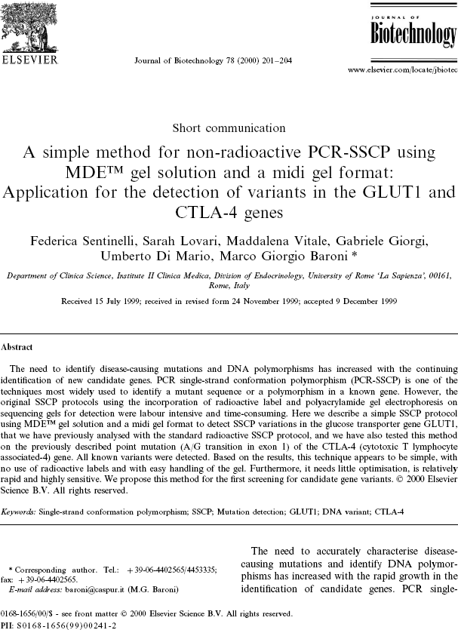

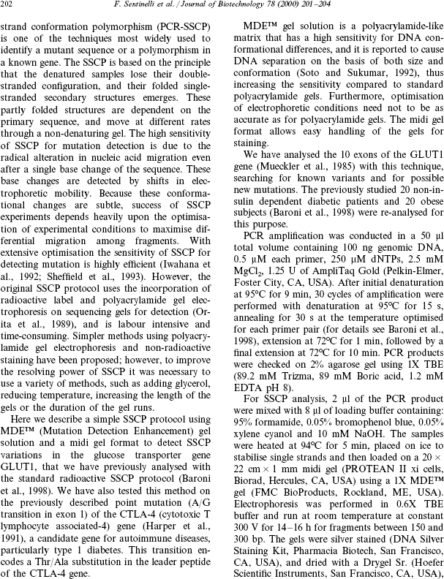

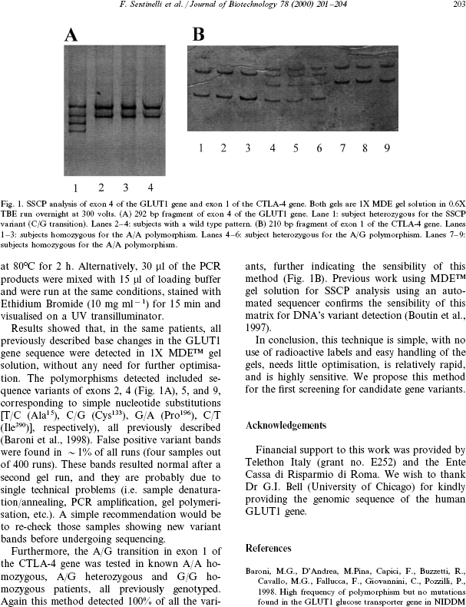

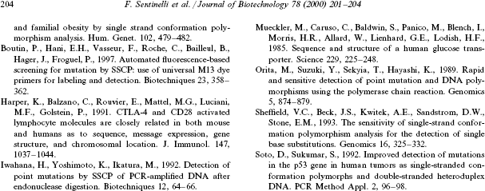

### Glossary

accurate ['ækjurit] chính xác

alteration [,ɔ:ltə'rei∫n] sự thay ñổi

anneal [ə'ni:l] tôi luyện

autoimmune [,ɔ:tou'imju:n] (bệnh) tự miễn

candidate ['kændidit] ứng viên

conduct ['kɔndʌkt] quản lí

configuration [kən,figju'rei∫n] hình dạng

conformation [,kɔnfɔ:'mei∫n] hình thái, hình thể

corresponding [,kɔris'pɔndiη] tương ứng với

denaturation [di:,neit∫ə'rei∫n] làm biến tính

denatured [di:'neit∫ə] làm biến tính

emerge [i'mə:dʒ] nổi rõ lên, lòi ra

encode [in'koud] mã hóa

exon ['eksɔn] vùng gen chính thức có chức năng phiên mã

experimental [eks,peri'mentl] (thuộc) thí nghiệm

extension [iks'ten∫n] kéo dài, duỗi

fold [fould] gấp, gập

fragment ['frægmənt] ñoạn, khúc

gel electrophoresis ñiện di trên gel

heavily ['hevili] ñậm, nặng, mạnh

heterozygous dị hợp

incorporation [in,kɔ:pə'rei∫n] sát nhập, hợp nhất

intensive [in'tensiv] tập trung, sâu sắc, chuyên sâu

matrix ['meitriks] khuôn

migration [mai'grei∫n] sự di chuyển, di trú

mutant ['mju:t(ə)nt] ñột biến, biến ñổi

obese [ou'bi:s] (người) béo phì

original paper/ research nghiên cứu nguyên bản

protocol ['proutəkɔl] qui trình, hiệp ước

radical ['rædikl] cơ bản, gốc rễ

radioactive ['reidiou'æktiv] chất phóng xạ

resolve [ri'zɔlv] giải quyết (khó khăn, vấn ñề)

review bài ñiểm báo, bài phê bình

sensitivity [,sensə'tivəti] ñộ nhạy

shift [∫ift] thay ñổi, luân phiên, theo ca

short communication thông báo ngắn gọn

stabilize ['steibilalz] ổn ñịnh

substitution [,sʌbsti'tju:∫n] thay thế

subtle ['sʌtl] không dễ phát hiện/ thấy, tinh vi

transition [træn'zi∫n] chuyển ñổi

variant biến thể

wild [waild] hoang, dại, bình thường

# “Animal body”

The body is made up of many, many millions of cells which you can not see unless you use a microscope. Special cells come together to make an organ.

An organ is a complex structure within the body. It has a special job or jobs to do.

A body system consists of a number of organs which work together to carry out a special job. The animal body is made of 9 systems (see table below)

job*.*

Various organs are grouped together to form a body system which carries out a special

|  |  |  |
| --- | --- | --- |
| **System of the Body** | **Organs in the Body** | **Job or function** |
| Musculo-skeletal | muscle (meat) bones | Support and move the body |
| Digestive | stomach, liver, intestine, pancreas | Digest and absorb feed |
| Circulatory | heart, blood vessels | The brood carries substances around the body |
| Respiratory | muzzle, windpipe, lungs | Breathing |
| Urinary | kidneys, bladder | Get rid of poisons and waste (urine) |
| Nervous | brain, nerves spinal cord | Pass messages around the body, control the body |
| Sensory | eyes, ears, nose skin | Sense and detect things outside the body |
| Reproductive | testes, penis ovaries, uterus, vagina, vulva, udder | To produce and feed young |
| Lympho-reticular | lymph nodes, spleen | Protect against infectious diseases, produce blood |

### The musculo-skeletal system

This system consists of the bones and the muscles (meat).The bones form the skeleton which is the framework within the body. It carries weight and supports the body.

Bones are connected together so they can move. The places where this happens are called joints. The bones are held together at the joints by elastic strands called ligaments. Between the bones is a softer material called cartilage (gristle) which cushions the bones at the joints when the body moves. Bones are very hard and contain minerals. Each bone has a name such as the scapula (shoulder blade) and skull (head). There are about 200 bones in the body.

Muscles are joined at both ends to the bones. The muscles are the meat of the body and when they contract (shorten) or relax (lengthen) they make the bones move.

If you bend your arm you can see and feel the muscles in your arm working.

### The digestive system

The digestive system consists of the teeth, mouth, gullet (oesophagus), stomach, liver, intestine, pancreas, and rectum.

Digestion begins in the mouth where feed is broken down into small pieces by the teeth and mixed with saliva before being swallowed.

In the stomach feed is mixed with the juices to form a soft paste. This then passes into the intestine where bile from the liver and juices from the pancreas are added. The action of these juices is to break down the feed and allow the nourishment it contains to be absorbed by the blood in the walls of the intestine. Waste matter collects in the rectum and passes out of the body through the anus (or cloaca in birds).

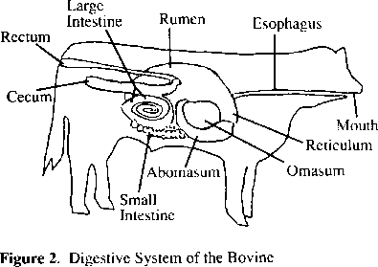

**Digestive system of the bovine**

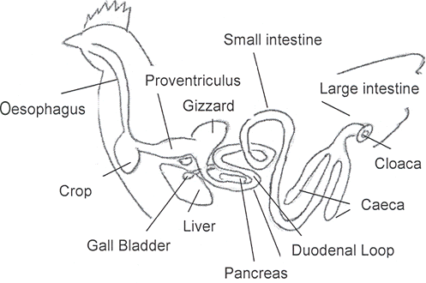

### Digective system of the chicken

**The circulatory system and blood**

The organs of the circulatory system are the heart and the blood vessels (tubes). The heart is found in the chest cavity. It is a muscular pump which sends blood around the body.

The blood vessels which carry blood away from the heart are called arteries. Blood returns to the heart in veins. Joining the arteries and veins is a fine network of small tubes called capillaries. The capillaries pass through every part of the body.

When the heart beats its muscles contract and sends blood out through the arteries.

When the heart relaxes blood flows into it from the veins.

Every time the heart beats it sends a pulse along the arteries. You can feel it at certain points on the body. By feeling the pulse we can count the rate at which the heart beats. You can feel your pulse on your wrist.

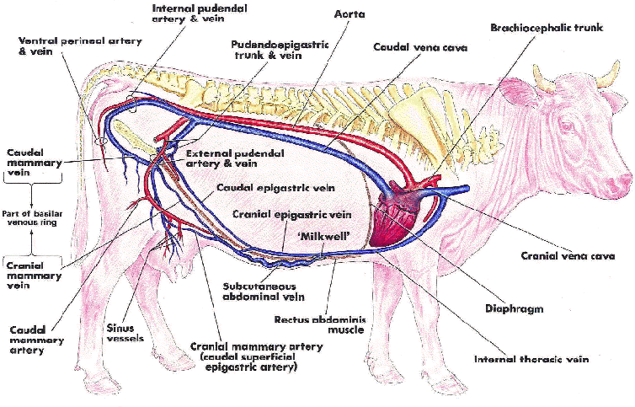

### The respiratory system

Respiration (breathing) consists of inspiration (breathing in) and expiration (breathing out).

There are two lungs which are found in the chest protected by the bony cage of the ribs. The windpipe carries air from the nostrils to the lungs which are spongy because of air spaces in them. As the animal breathes, air moves in and out of the lungs. Inside the lungs oxygen needed by the body passes into the blood in the walls of the lungs and water and carbon dioxide pass out of the blood into the air which is then breathed out.

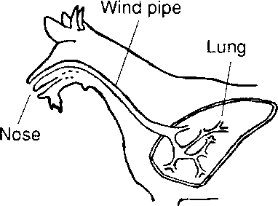

### The urinary system

The main organs are the two kidneys, which lie against the backbone, and the bladder.

Waste materials and water are taken out of the blood in the kidneys. This forms urine.

Urine collects in the bladder then passes out of the body.

### Nervous system and sensory system

The bones of the skull and backbone protect the soft brain and spinal cord. Fibres called nerves pass from the brain and spinal cord to all parts of the

Messages pass from the various parts of the body along the nerves to the brain. The brain sends a message back telling the different parts of the body what to do.

The brain controls the body.

### Nervous system

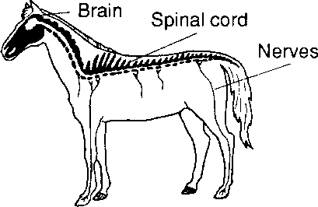

The brain also controls the senses, the sense organs are: the eyes for sight; the ears for hearing; the nose for smell; the tongue for taste; the skin for touch.

### Reproductive system (breeding)

The male reproductive organs, the testicles, lie in the scrotum behind the penis. The testicles produce sperm which are contained in the fluid semen. A tube passes from each testicle and joins to form a tube which runs down the centre of the penis.

In the bird the testicles are inside the body.

### Reproductive and urinary organs of the male

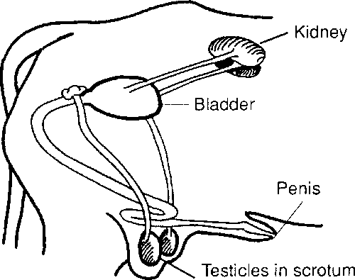

The female reproductive organ consist of two ovaries, one in each side of the lower abdomen. The ovaries produce eggs which pass into the uterus (or womb). Below the uterus is the vagina which opens to the outside surrounded by the vulva. After birth the young are fed on milk produced by the udder.

### Female reproductive and urinary system

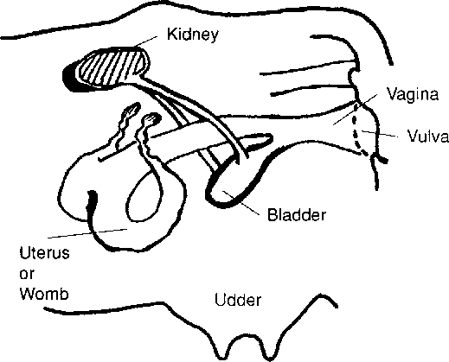

During mating (mounting) sperm passes from the male into the uterus and joins with the eggs there. When the sperm joins the egg it forms the embryo which develops into the young animal inside the uterus.

Reproduction is controlled by hormones (chemical messengers) which are carried in the blood to the different organs.

These hormones control: Puberty of the animal; Production of eggs; Birth; Production of semen; Development of the embryo; Milk production.

### Lympho-reticular system

Lymph is a colourless fluid which passes out of the blood into a network of fine tubes called the lymphatic system. It passes through the lymph nodes, where germs are filtered out and killed, before it is returned to the veins. The lymph nodes and spleen also produce special blood cells which protect the body against disease. Sometimes when an animal is infected the lymph nodes become swollen and can be felt beneath the skin.

Nguồn: <http://www.fao.org/docrep/T0690E/t0690e04.htm>

abdomen ['æbdəmen] bụng

anus ['einəs] hậu môn

artery ['ɑ:təri] ñộng mạch

bladder ['blædə] bàng quang

blade [bleid] xương dẹt

capillary [kə'piləri] mao mạch

cartilage ['kɑ:tilidʒ] sụn

caudal ['kɔ:dl] ñuôi

cavity ['kæviti] xoang, khoang

circulatory ['sə:kjuleitəri] thuộc tuần hoàn

cloaca [klou'eikə] lỗ huyệt

cranial ['kreinjəl] thuộc sọ

crop diều

cushion ['ku∫n] ñệm

digestive [di'dʒestiv] thuộc tiêu hóa

elastic [i'læstik] ñàn hồi

gizzard ['gizəd] mề

gristle ['grisl] xương sụn

gullet ['gʌlit] thực quản

joint [dʒɔint] khớp xương

kidney ['kidni] thận

ligament ['ligəmənt] dây chằng

lymph [limf] bạch huyết

lympho-reticular thuộc lưới /hệ thống bạch huyết

mounting ['mouldiη] lên giống

musculo-skeletal thuộc xương cơ

nervous ['nə:vəs] thuộc thần kinh

nourishment ['nʌri∫mənt] thực phẩm

oesophagus [i:'sɔfəgəs] thực quản

ovary ['ouvəri] buồng trứng

penis ['pi:nis] dương vật

proventriculusz [prouven'trikjuləs] dạ dày tuyến

pudendum [pju:'dendəm] bộ phận sinh dục ngoài

reproductive [,ri:prə'dʌktiv] thuộc sinh sản

respiratory [ri'spaiərətri] thuộc tiêu hóa

scapula ['skæpjulə] xương bả vai

scrotum ['skroutəm] bìu dái

sensory ['sensəri] thuốc cảm giác, giác quan

skull [skʌl] sọ

spinal cord ['spainl'kɔ:d] tủy sống

testicle ['testikl] tinh hoàn

udder ['ʌdə] vú

urinary ['juərinəri] thuộc tiết niệu

uterus ['ju:tərəs] tử cung

vagina [və'dʒainə] âm ñạo

vein [vein] tĩnh mạch

ventral ['ventrəl] của bụng

vulva ['vʌlvə] âm hộ

windpipe ['windpaip] khí quản

womb [wu:m] tử cung, dạ con

UNIT 1: Crops around the world

1. Vocabulary

1.1. Find the words which have similar meaning.

|  |  |  |
| --- | --- | --- |
| a. | store (v) | - thing / substance |
| b. | cleanse (v) | - break down |
| c. | mineral fraction (n) | - extent / size |
| d. | interaction (n) | - clean |
| e. | decay (v) | - keep |
| f. | measure (n) | - small piece |
| g. | organic matter (n) | - act to each other |
| h. | particle (n) | - mineral component |

* 1. Grouping. Which group do the following words belong to?

Potato; tomato; pineapple; papaya; longan; wheat; soya; rubber; cacao; rice; cucumber; carrot; lemon; bean; peach; cotton; pear; tea; manioc; orange; coffee; sugar cane; peanut; strawberry; cauliflower; cabbage; banana; water melon . . .

1. Fruit trees
2. Vegetables
3. Industrial crops
4. Food crops
5. Shallow-rooting crops
6. Root crops
7. Tree crops
8. Look at the diagram and answer the questions below.
9. Soil profiles.

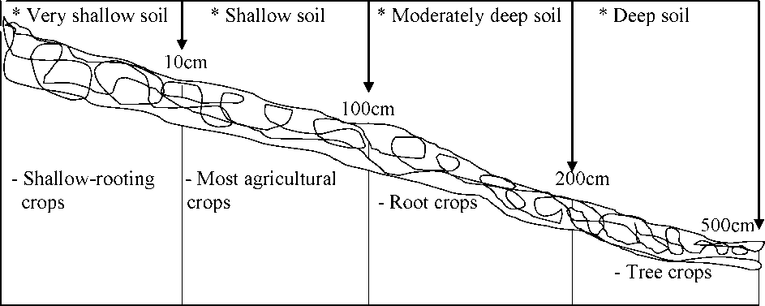

1. Exercise 1. (pair-work) Now ask and say about other soil-type of the soil profile as example.

A: What is the depth of a shallow soil?

B: A shallow soil has a depth of 10 to 100 cm.

A: What crops is a shallow soil suitable for?

B: For shallow rooting crops.

A: What are shallow rooting crops composed?

B: Banana; pineapple,... (give examples in your own area.) B. Soil particle size.

|  |  |
| --- | --- |
| Types of soil | Particle diameter range in mm |
| - coarse sand | 1.0 - 0.2 |
| - fine sand | 0.2 - 0.05 |
| - silt | 0.05 - 0.002 |
| - clay | < 0.002 |

Small soil particles are called sand, silt or clay particles, according to their size.

1. Speaking. (pair-work) Ask and answer about the following soil particles.

Example

A: What is the diameter range of coarse sand particles?

Coarse sand Fine sand Silt Clay

B: Coarse sand particles are between 2 and 0.2mm in diameter.

A:

B:

A:

B:

1. Soil texture and structure.

Soil texture is the proportion of different particle sizes in the soil. Soil with very small particles (clay) has a fine texture. Soil with a mixture of small and large particles (loam) has a medium texture. Soil with large particles (sand) has a coarse texture. The range of textures can be shown on a soil texture diagram. For example, soil sample A has 10% sand, 20% silt and 70% clay. It falls at point A on the diagram. What is the soil texture of soil sample A?

1. Look at soil sample A:

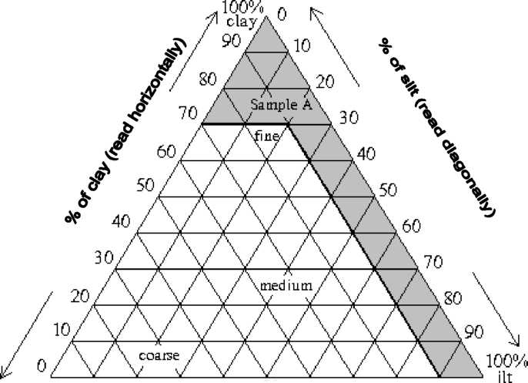

100% 90 SO 70 60 50 40 30 20 10 0&

^ % efsand (read djagcDally) ^

Soil sample A has 10% sand, 20% silt and 70% clay. Thus it has a ...fine... texture. Now look at the following soil samples in the table.

a. Fill in the blanks. What is the texture of the following soil samples?

|  |  |  |  |
| --- | --- | --- | --- |
| Samples | Sand | Silt | Clay |
| B | 60% | 30% | 10% |
| C | 30% | 50% | 20% |
| D | 40% | 30% | 30% |

1. Read and complete the following passage.

Soil with a coarse texture consists of relatively large particles. Thus it retains air in the spaces between the particles, but it does not retain water. Coarse-textured soils are usually well drained. However, many important nutrients are leached out of the soil. These soils are usually red or brown in colour.

A medium-textured soil consists of a mixture of ...(1)... and ...(2)... particles. ...(3)... it

retains ...(4)... and ...(5) (6) (7)... are usually imperfectly drained. Therefore

important plant ...(8)... are available for plant growth. These soils are usually ...(9)... or ...(10)... with grey mottles.

A fine-textured soil consists of relatively ...(11) (12)... Thus it ...(13)... water, ...(14)...

it does not hold ...(15)... . Fine-textured soils are blue or green in ...(16).. . They are ...(17... ...(18)... drained.

The words may be used to fill the gaps.

thus ; water ; small ; soils ; large ; medium-textured ; brown ; nutrients red ; particles ; holds ; small ; air ; but ; poorly ; colour ; usually ; nutrients

1. Answer the following question.
2. Why does a coarse-textured soil retain air?
3. Give one disadvantage of a coarse-textured soil.
4. Why is a medium-textured soil usually imperfectly drained?
5. Are the particles of a fine-textured soil predominantly sand, silt or clay?
6. Why is the fine-textured soil often flooded after rain?
7. Why is rice often grown in a fine-textured soil?
8. In which type of soil are root crops (e.g. sweet potato, cassava, etc) grown in your area? Give one reason why you think this is so.

D. Soil structure. Define the soil texture as quickly as possible, then write the soil structure.

* Soil texture: A: B: C:
* sand 80% - sand 20% - sand 20%
* silt 10% - silt 70% - silt 20%
* clay 10% - clay 10% - clay 60%

1. Translation
2. Discussion
3. Read and complete.

Sample A is a coarse-textured soil, sample B is a medium-textured soil and sample C is a fine-textured soil. Each sample is mixed with water and shaped like a ball. What happens when water drips onto each sample?

* The coarse-textured soil breaks up easily. It has a loose structure.
* The medium-textured soil moderately easily,

friable structure.

* The - does not

solid structure.

1. Speaking. (pair-work) Answer the following questions.
2. Why is it difficult to cultivate a fine-texture soil?
3. Why is a medium-textured soil suitable for plant growth?
4. What happens to coarse-textured soil in a heavy rain storm?
5. What are the advantages of each type of soil?
6. What are the disadvantages of each type of soil?
7. How can farmers cultivate a coarse-textured soil?
8. How can a fine-textured soil be used most efficiently?
9. READING A
10. Pre-reading task.
11. Find the difference between soil, land and earth.

SOILS

Soils are very complex natural formations which make up the surface of the earth. They provide a suitable environment in which plants may obtain water, nutrients and oxygen for root respiration, and firm anchorage. Soils are formed by the weathering of rocks, followed by the growth and decay of plants, animals, and soils micro-organisms. If a farmer is to provide the best possible conditions for crop growth, it is desirable that he should understand what soils are, how they were formed and how they should be managed.

The topsoil and surface soil is a layer about 8-45 cm deep which may be taken as the greatest depth which a farmer would plough or cultivate and in which most of the plant roots are found.

Loose, cultivated, topsoil is sometimes called mould.

The subsoil, which lies underneath, is an intermediate stage in the formation of soil from the rock below.

A soil profile is a section taken through the soil down to the parent rock. In some cases this may consist of only a shallow surface soil 10-15 cm on top of a rock such as chalk and limestone. In other well-developed soils (about a metre deep) there are usually three or more definite layers (or horizons) which vary in colour, texture and structure.

The soil profile can be examined by digging a trench or by taking out cores of soil from various depths with a soil auger.

A careful examination of the layers (horizons) can be useful in forming an opinion as to how the soil was formed, its natural drainage and how it might be farmed. Some detailed soil classifications are based on soil profile.

1. Check your understanding.
2. Read the text carefully, then answer the following questions:
3. What are the four main constituent parts of soil?
4. What should the farmer understand about soil?
5. How many types of soil are there?
6. What soil is called mould
7. How are soils formed?
8. How do you take a soil sample?
9. What can a soil sample tell you?
10. Find the words with opposite meaning to the following words in the passage.

* simple : - development : - concentrating :
* loose : - deep : - single :
* not wanted : - wash away : - general :

1. Look at paragraph 2 and say what these words refer to:

line 1: which line 9:

line 2: which line 13:

line 8: which line 17:

1. Look at the passage again. Which words correspond to the definitions below:
2. how particles are arranged in a substance
3. the process of pressing particles closely together
4. a ditch dug in the ground
5. the middle, or most important, part of anything
6. a system for taking away water
7. a group into which something is put
8. what is based on to classify soil in full detail
9. loose cultivated surface soil.
10. small organisms living in soil.
11. prepare and use land for growing crops

UNIT 4: Diseases of tropical fruit trees

1. Fill in the gaps with given words.

due to ; erode ; waterlogged ; compound ; presence ; friable ; laterite ; penetrate

1. Metals are by acids.
2. Common salt is a of sodium and chlorine.
3. The train was delayed the bad weather.
4. The dogs were trained to detect the of drug.
5. Soil with large particles is
6. Almost roads in the countryside are made of
7. The heavy rain had right through her coat.
8. The area is often in rainy season.
9. READING A.
10. Pre-reading task.
11. What countries are tropical?
12. Read the passage and answer these questions as quickly as possible.
13. What colour is laterite?
14. What are the three major soil types mentioned in the passage?

TROPICAL SOIL

The soil of hot, tropical areas varies in texture, structure and colour and in their value for agriculture. A group called Tropical Red Earths is a very common soil type in, for example, tropical Africa. The group includes yellow, orange and brown soils as well as red. Their colour is due to the presence of certain minerals, mainly iron and aluminium oxides. They are usually rich in clay but they are quite friable and easily cultivated. A common type of soil in this group is laterite. It is a red-brown soil, which becomes very hard when it is dry. Laterite often forms a very hard crust on or below the surface. Plants are unable to grow through it and water cannot penetrate it. These soils are usually eroded by water running over the surface.

Black or dark-coloured soils are found in lowland areas, which become flooded or waterlogged, and in valleys. They are usually rich soils and valuable for cultivation (rice). The grey and light-coloured soils contain calcium compounds and are often found over limestone rock.

1. Say whether the information in the following sentences is true or false. Correct any false or partly false information.
2. There is only one type of soil in tropical countries.
3. Soils which are rich in iron oxides are common in tropical Africa.
4. These soils are fine-textured and usually solid in structure.
5. Laterite is an example of Tropical Red Earths.
6. Laterite has properties which make it difficult for plants to grow.
7. Laterite is a well-drained soil.
8. Important nutrients are leached out of laterite soils.
9. Black or dark-coloured soils are poorly drained.
10. Black or dark-coloured soils usually have large soil particles.
11. Black or dark-coloured soils retain important plant nutrients.
12. Writing and speaking. Answer the following questions
13. Can you say anything about the pH value of Tropical Red Earths from the information given in the passage?
14. Find out about the properties of soils in your area. (type of soil, colour, texture and structure of the soil). Which crops grow on them?
15. The pH value of soil water.

We use the pH scale to describe the acidity or alkalinity of a soil. A soil with a pH value between 1 and 6 is acid, whereas a soil with a pH value of 7 is neutral and a soil with a pH value between 8 and 14 is alkaline. Most soils have a pH value between 8 and 6. Most crops do not grow well in very acid or very alkaline soils.

. tea. coffee. citrus. bananas

tt t tt tt

1 2 3 4 5 6 7 8 9 10 11 12 13 14

1. Writing1. Now make similar sentences about tea, coffee, citrus crops, rice, tomato and

sweet potatoes as the given example.

Example: Bananas grow well in slightly acid or neutral soil, but they do not grow well in very acid soil.

1. Tea
2. Coffee
3. Citrus
4. tttttttttttttttttttttttttttttttt
5. ttttttttttttttttttttttttttttttt..
6. Writing 2. Write comparison

Example: blackberry/cherry. Blackberry grows well in acid soil, but carrot doesn’t.

1. grape/cauliflower
2. soybean/celery
3. onion/peanut
4. tttttttttttttttttttttttttttttttt .
5. tttttttttttttttttttttttttttttttt .
6. tttttttttttttttttttttttttttttttt .

|  |  |  |
| --- | --- | --- |
| A | cid and Alkaline Tolerance | |
| Quite acid (4.0 - 6.0) | Slightly acid (6.0 - 7.0) | Neutral to alkaline (7.0 - 7.5) |
| - blackberry | - apple | - alfalfa |
| - blueberry | - apricot | - beet |
| - bracken | - beans | - broccoli |
| - chestnut | - buckwheat | - cabbage |
| - coffee | - cherry | - carrot |
| - conifer | - egg-plant | - cauliflower |
| - lupine | - gooseberry | - celery |
| - marigold | - grains | - clover |
| - moss | - grape | - cucumber |
| - oak | - parsley | - leeks |
| - potato | - pea | - lettuce |
| - peanut | - peach | - onion |
| - raspberry | - pear | - silver beet |
| - sweet potato | - pumpkin | - spinach |
| - tea | - soybean | - swiss chard |
| - watermelon | - strawberry tomato | - zucchini |

Acid and alkaline tolerances of selected crops.

1. Exercise 3. (pair-work)

Ask and say about the tolerance of the crops in the box as example below.

* A: What crops grow well in an acid soil?
* B: Blackberry, potato and watermelon grow well in acid soil.
* A: What crops do not grow well in an acid soil?
* B: The crops do not grow well in an acid soil such as: onion, spinach and cauliflower.
* A: In what soil do beans grow well?
* B: Beans grow well in slightly acid or neutral soil, but they do not grow well in very

acid soil.

1. READING B
2. Read the following passage and answer these questions.
3. Which of these would you expect to find in tropical soils? Discuss and explain your answers.

* soil erosion
* nutrient deficiency
* an excessive amount of water
* an insufficient quantity of water
* an excess of nutrients

1. How much kaolinite clay do tropical soils usually contain?
2. What is this section of the reading passage about?

* tropical soils and their management
* the differences between tropical and temperate soils
* the differences between tropical and temperate soil management.

THE MANAGEMENT OF TROPICAL SOILS The management of tropical soils involves different principles from those of temperate soils. This is because both the climate and the soils are different. In the tropics there is a low temperature range and a high average temperature. The rainfall is usually very heavy in the rainy season but inadequate in the dry season, where there is one.

Tropical soils contain a large amount of kaolinite clay and if they are low in iron and aluminium, their structure may be excessively poor and unstable. If, on the other hand, the soil contains adequate amount of iron and aluminium, their oxides and hydroxides will cement the kaolinite particles together in relatively large aggregates and this will improve soil structure.

When managing tropical soils, therefore, two basic principles are involved. The first is to use a method of farming which involves a minimum of clean cultivation since the latter leaves the soil bear and consequently liable to water erosion and loss of nutrients by leaching. The second is to use a method which maintains sufficient organic matter in the surface soil. This helps to keep bases and phosphates available in the soil, is a good source of plant nutrients and maintains good structure in the surface soil.

1. Writing and speaking. (pair or group-work) Find the answer to the followings.
2. Give two ways in which tropical climates differ from temperate climates.
3. Name two common bases found in some tropical soils.
4. Name two factors, which improve soil structure and explain their effect.
5. Explain why a soil may contain insufficient phosphates.
6. Give one function of iron oxide in the soil.
7. Give the two advantages of each of the basic principles in managing tropical soils.
8. Grammar SENTENCES and SENTENCE PATTERNS
9. Phrases and Clauses.

The various parts of speech are grouped into phrases and clauses which make up the basic sentence.

1. Phrases.

Phrases are groups of related words that do not contain a subject-verb combination or express a complete thought. There are noun, prepositional, participial, verb and infinitive phrases.

* Noun phrase: - my brand new car - the famous film star
* Prepositional phrase: - over the wall - around the block
* Participial phrase: - playing the piano - buying the book
* Verb phrase: - will be given - is coming
* Infinitive phrase: - to think - to draw

1. Clauses.

Clauses are groups of related words that contain a subject-verb combination. Independent clauses express a complete thought and can stand by themselves as sentences. Subordinate clauses serve as part of a sentence but do not express complete thought and cannot stand by themselves. They are subordinate to independent clauses.

* Independent clauses:
* the weather was warm and dry
* John got free tickets to the play
* They took the wrong road
* Subordinate clauses:
* by the time June arrived
* because he works at the theatre
* when they came to the turn

Complete sentences:

* By the time June arrived, the weather was warm and dry.
* John got free tickets to the play, because he works at the theatre.
* When they came to the turn, they took the wrong way.

1. Practice. Analyze the following sentences
2. Underline and name the phrases in the following sentences.
3. We have only three days to practise until the band contest.
4. In this case some of the nitrate retains in the subsoil.
5. This gives two further important principles in tropical soil management.
6. The first of these is to prepare the land and sow the crops early enough to use the surplus nitrogen after the dry season.
7. The second is to grow crops with sufficiently deep roots to use nitrogen before it is washed into subsoil.
8. Find and underline the clauses in the following sentences.
9. Precipitation is rain, snow, fog, sleet, hail and frost, which undergo two main processes: condensation and evaporation.
10. The place where you live is a microclimate of the large general climate.
11. Microclimates can be a rich source of diversity, so your design should take advantage of them rather than eliminate them.
12. You can create different habitats and diversify the range of plants and animals that will grow in your garden.
13. You may be able to grow an almond tree if you live in a cool moist climate simply by positioning it against a sunny sheltered wall.
14. Although much farming is still by traditional methods, there has been a significant change in the technologies available since independence.
15. The raising of livestock, particularly horned cattle, buffalo, horses, and mules, is a central feature of the agricultural economy.
16. The demand for chemical fertilizers and high-yielding seed varieties has increased markedly, particularly since the much-publicized “Green Revolution” of the 1960s and early 1970s - which particularly benefited richer farmers in wheat-growing areas like Uttar Pradesh and Punjab states.

UNIT 6: Integrated pest management on fruit crops and vegetable

1. Word study.
2. Find the words in the text which have similar meaning to the following words.
3. define : a 6. suitable: f.
4. firm: b 7. fund: g
5. norm: c 8. project: h
6. collective: d 9. provide: i

5. usual: e 10. systems: j

3. Discussion

* 1. Agricultural policy

Agricultural policy in the United Kingdom since 1973 has been determined primarily by Common Agricultural Policy (CAP) of the EU, which aims to ensure stable markets, a fair standard of living for producers, and regular supplies of food at reasonable prices for consumers. The costs to EU taxpayers of the CAP, which accounts for more than 50 per cent of the EU’s budget, and the mechanisms of maintaining farm prices through grants and subsidies, and through tariffs on cheaper imports, have come under increasing criticism since the early 1980s by Britain, by developing countries, and by the United States.

Various reforms have been implemented in an attempt to reduce costs, subsidies, and the huge levels of overproduction, which generated „’butter mountain” and „’wine lakes” during the 1970s and 1980s. These have included schemes to encourage farmers to take land out of agricultural production, to adopt more environmentally kind, but less productive methods of farming, to impose production quotas on certain products, like milk, and to reduce subsidies on others.

In Britain agricultural marketing is carried out by private traders, producers’ cooperatives, and marketing boards for certain products. The number of marketing boards has been steadily reduced over the past 20 years. In November 1994 one of the largest, the Milk Marketing Board for England and Wales, ceased to exist and was replaced by a producers’ cooperative, Milk Marque.

Britain’s food industry is one of the world’s largest and most successful, with a highly developed retail, supply, and distribution network. Its supermarket chains supply an ever- increasing choice of food products to the British consumer and are among Europe’s most profitable companies. The 1997 merger of Guinness and Grand Metropolitan created one of the world’s biggest food and drinks conglomerates.

1. Practice. New words are formed by adding a suffix to other words.

Find the words formed in this way in the passage to complete the exercise below.

1. produce * production 2. employ * employment 3. produce * producer

* contribute * - require * - *
* compact * - manage * - *
* examine * - * - *

- * - * - *

* * - * - *

4. reason * reasonable 5.product *productive 6.agriculture * agricultural

* desire * - * - *
* suit * - * - *

1. Complete the following sentences, using the right form of the given word.
2. The government gives some subsidies to the basic food to the normal

production. (maintenance)

1. Five dollars for a big chicken is enough in New York. (reason)
2. There should be a complete of all the local authorities. (implement)
3. British Agriculture .just 2% of the population and 1.9% of GDP

but it achieves high levels of efficiency and (employment; contribution ;

produce)

1. Will the new power station be able to supply us cheap energy ? (require)
2. Agricultural policy aims to ensure stable markets, a fair standard of living for ,

and regular supplies of food at prices for consumers. (produce ; reason)

1. Various reforms have been in an attempt to reduce costs, subsidies, and the

huge levels of (implementation ; overproduce)

1. In Britain agricultural marketing is carried out by private traders, producers’ , and marketing boards for certain (cooperate; produce)
2. Comprehension check.
3. What are the main points of the policy?
4. What is the aim of the policy?
5. Who gets the most benefits from the policy?
6. Are there any agricultural policies in your country?
7. Do the policies help to develop the agriculture?
8. What is the agriculture of your country?
9. What is the most dominant sector in the agriculture?
10. Where is rice mainly grown?
11. What population does the agriculture employ?
12. What percentage of GDP does the agriculture account for?
13. What do you think about your agriculture now and in he future?
14. Are there any plans for developing your agriculture?
15. According to you can we develop our livestock rising like Holland or USA?
16. As a future agronomist do you have any special plans for the agriculture?
17. What economic sector can be developed best in our agriculture?

PART B. I. READING C.

1. Pre-reading task.

1. Is India in Europe?
2. What is Indian agriculture?
3. What agricultural products of India are popular in the world?

AGRICULTURE OF INDIA

About two-thirds of India’s population depends on the land to make a living. Agriculture generates an estimated 28 per cent of gross domestic product (GDP). Most farms are very small - the average size of holding nationally is 2.63 hectares, but more than a third of holdings are considered too small for the subsistence needs of farming family. In term of area sown the leading crop is rice, the staple food of a large section of the Indian population. Wheat ranks next in importance to rice, and Indian also among the leading producers in the world of sugar cane, tea, cotton, and jute. Annual production of these commodities in the mid-1990s was sugar cane, 275.5 million tones; rice, 82 million tones; wheat, 65.8 million tones; tea, 737,400 tones; cotton lint, 1.9 million tones; and jute, 1.5 million tones. Other important crops are vegetables, melons, sorghum, millet, maize, barley, chickpeas, bananas, mangoes, rubber, coffee, linseed, groundnuts (peanuts), and various spices.

The raising of livestock, particularly horned cattle, buffalo, horses, and mules, is a central feature of the agricultural economy. In the mid-1990s India had about 193 million cattle, substantially more than any other country in the world. These animals, like buffaloes, horses and mules, are utilized primarily as beasts of burden, although the vegetarianism associated with the Hindu custom is followed by few, especially in north India. Lack of pasture and water supplies means most Indian cattle are of poor quality. The country’s 78 million buffalo are largely raised in the delta regions. In the dry regions of Punjab and Rajasthan camels (1.5 million) are the principal beasts of burden. Sheep (44.8 million) and goats (118 million) are raised mainly for wool.

Although much farming is still by traditional methods, there has been a significant change in the technologies available since independence. The area under canal irrigation systems financed by the government has expanded enormously; there has been an even greater expansion in the area watered by well-based systems. By the early 1990s about 45 per cent of the total cultivated area was irrigated. The demand for chemical fertilizers and high-yielding seed varieties has increased markedly, particularly since the much-publicized “Green Revolution” of the 1960s and early 1970s - which particularly benefited richer farmers in wheat-growing areas like Uttar Pradesh and Punjab states.

1. Comprehension check.
2. Find the word or words, which may link with the following to make a phrase.

* Example:

1. method (noun phrase) b. depend (verb phrase)

S traditional method Sdepend wholly

S effective traditional method Sdepend wholly on the land

S an effective traditional method Sdepend wholly on the land for food

* practice.

|  |  |  |  |  |
| --- | --- | --- | --- | --- |
| 1. | governments | 1. | consider | S |
| 2. | area S | 2. | cultivate | S |
| 3. | systems S | 3. | lead | S |
| 4. | economy S | 4. | increase | S |
| 5. | expansion S | 5. | produce | S |
| 6. | region S |  | grow | S |
| 7. product S | | tttt 6. ttt 7. | supply | S |

8. farm

1. irrigate -*.
2. utilize
3. change -*.
4. crops
5. fertilizer
6. Answer the following questions.
7. How many percent of gross domestic product does Indian Agriculture generate?
8. What size are farms in India?
9. What are the main farming products of Indian Agriculture?
10. How many cattle are raised in India?
11. Where are most buffaloes raised?
12. Why are most Indian cattle of poor quality?
13. What are camels in India mainly used for?
14. What is the Green Revolution about?
15. What agricultural products does India export to other countries?
16. Why isn't the raising of livestock in India increased?
17. Writing.
18. Write out five leading agricultural products of India.
19. Write about the raising of livestock in India.

Make hay while the sun shines

§ UNIT 3 SOILS - A LIVING ORGANISM I. Word study.

1. Which set of words do the definitions refer to?
2. Get back from used material by treating it.
3. micro-organism.
4. soil materials.
5. soil improvers.
6. cycle waste.
7. force of gravity.
8. soil texture.
9. soil structure.
10. Force that attracts objects in space towards each other and on the earth pulls them towards the centre of the planet.
11. Way a surface of soil looks firm, soft or hard.
12. Way in which the mineral fractions together build the soil.
13. Organism so small that it can be seen only under a microscope.
14. Substance from which soil is built.
15. Way or techniques that assist micro-organisms and nutrients in

soil in increase.

1. Match the word on the left with the word with opposite meaning on the right.

|  |  |  |  |
| --- | --- | --- | --- |
| 1. alkali solution | a. develop | 11. adequate | k. release |
| 2. soluble | b. decline | 12. decay | l. alkaline |
| 3. absorb | c. lose | 13. increase | m. dry |
| 4. acidic | d. centrally | 14. mulch | n. percolation |
| 5. moisture | ... e. deposit | 15. promote | o. inorganic things |
| 6. evaporation | .... f. poisons | 16. solubility | p. build-up |
| 7. roots | ... g. decrease | 17. nutrients | q. harmful |
| 8. organic matter | ... h. keeping | 18. leaching | r. lack |
| 9. breakdown | i. acid solution | 19. laterally | s. bear |
| 10. beneficial | j. precipitable | 20. benefit | t. leaves |

1. READING A:
2. Pre-reading questions.
3. Is soil a living organism? Why do people think of soil as a living organism?

SOILS - A LIVING ORGANISM

You can think of soil as living organism which recycle waste, promotes active growth, stores and cleanses water, and act a basic life source for all living things. And like all living things, soil can be healthy or unhealthy.

A healthy soil has a good balance of water, gases, mineral fractions, living organisms and decaying organic matter. Together these components interact to give life to the soil.

Soil Components

1. Water / moisture

Water in soil becomes a weak acid or alkali solution, which carries the soluble nutrients that plants absorb through their roots.

We talk about the pH of the solution; the pH refers to acidity or alkalinity which, in soils, is a measure of solubility of nutrients. The pH is measured on a scale of 0 to 14. If a soil has a pH of 8 then some nutrients will be more soluble than others and the soil is said to be alkaline. If a soil has a pH of 5 then the solubility of its nutrients will be different and the soil is said to be acidic. A soil with a pH of 7 is neutral.

Soil pH can be changed by adding lime to an acid soil to make it more alkaline, and sulphur can be added to an alkaline soil to make it more acidic. Most plants grow within a pH range of 5.5 to 8.

It is important to understand how water moves through the soil so that when you add water you can help to keep it there and prevent leaching of valuable plant nutrients. Water moves through the soil under the force of gravity. While plant roots absorb some of the water, much of it moves downwards into the lower soil layers and is eventually absorbed into the

underlying water table. During periods of heavy rain or over-watering, soil nutrients are washed from the root zone.

Moisture moves upwards due to the evaporative effects of sunlight and wind, and from the pull of soil water by the plant roots to the leaves.

By reducing evaporation from the soil surface and percolation you can increase the amount of water available to plant roots. This can be achieved by surface mulching, digging organic matter into the soil and constructing swales.

Water also moves laterally along bedding rocks in the water table. You can plant deep- rooted plants to benefit from this water source.

1. Air

Gases in soils change their pressure and type during the day and different seasons. They also move into and out of soils. How freely they move depends some extent on the texture and structure of the soil.

Gases in the air are exchanged with those given off by plant roots and by soil micro­organisms. If there is adequate oxygen then soil tends to be sweet smelling. If there is little oxygen then other gases such as sulphur dioxide can build up and the soil will smell rotten.

It has recently been found that ethylene gas is particularly beneficial to plant growth. (Ethylene gas is known as the 'ripening' gas and is given of as bananas, oranges and other fruit ripen.) In soil ethylene cycles with oxygen, increasing the build-up of micro-organisms and other soil materials. Techniques that let more oxygen into the soil, such as forking small areas or deep-ripping fields, are soil improvers because they assist the ethylene cycle.

1. Comprehension check.
2. Are the following statements true or false according to the passage?
3. Soil can promote the active growth of trees.
4. The pH is a measure of solubility of nutrients.
5. A soil which has a pH under 7 is said to be acidic.
6. Farmers often add some lime to a soil to make it more acidic.
7. Moisture may move upwards due to the evaporative effects of sunlight and wind.
8. Soils are different from each other because they have the different pH of solubility.
9. When water moves through the soil, it may bring plant nutrients into water table.
10. How freely gases move out of soil depends on the texture and structure of the soil.
11. Oxygen with ethylene may help to increase the build-up of micro-organism.
12. One of the techniques of improving soils is to let more oxygen into the soil.
13. Soil is considered as living organism because it acts as a basic life resource for all living things.
14. The pH of the solution in a soil is never changed.
15. The understanding how water moves through the soil is very important for farmers to prevent leaching of valuable plant nutrients when watering.
16. Mulching the soil surface or digging organic matter into the soil can reduce evaporation from the soil surface.
17. Speaking (pair or group-work) Ask and answer the following questions.
18. What are the main soil components?
19. How do they interact to each other?
20. What soil is regarded to be healthy and what unhealthy?
21. What is the PH value?
22. What can the PH tell you about the soil?
23. Translation. Translate the following sentences into Vietnamese.
24. A healthy soil has a good balance of water, gases, mineral fractions, living organisms and decaying organic matter. Together these components interact to give life to the soil.
25. Water in soil becomes a weak acid or alkali solution, which carries the soluble nutrients that plants absorb through their roots.
26. We talk about the pH of the solution; the pH refers to acidity or alkalinity which, in soils, is a measure of solubility of nutrients.
27. It is important to understand how water moves through the soil so that when you add water you can help to keep it there and prevent leaching of valuable plant nutrients.
28. While plant roots absorb some of the water, much of it moves downwards into the lower soil layers and is eventually absorbed into the underlying water table.
29. Gases in soils change their pressure and type during the day and different seasons. They also move into and out of soils. How freely they move depends some extent on the texture and structure of the soil.
30. Gases in the air are exchanged with those given off by plant roots and by soil micro­organisms.
31. GRAMMAR. SUBJECT and PREDICATE

The subject is the topic of the sentence. The predicate is what is said about the subject. Subject Predicate

* The balloon floated up through the trees.
* New York City is the major cultural centre.
* The lion tamer astonished the audience.

In most cases, as in the preceding examples, the subject of a sentence comes first, followed by the predicate. However, there are instances when the subject is placed after the predicate, omitted from the sentence, or placed inside the verb.

* Into the valley of death rode the six hundred.
* Wash the car by tonight. (subject 'you' is understood)
* Are your parents coming tomorrow?
* There are four chickens in the yard. (there occupies the place of the subject, but four chickens is still the subject of the sentence)

1. Forms of the subject

The most common forms of the subject are nouns, pronouns, and proper nouns.

* Carol came to the party last night.
* Why don't you pick up some lettuce for tonight?
* Who left these socks here?

At times, noun phrases and clauses, gerunds and gerund phrases, and infinitive phrases can also function as the subject.

* Noun phrase: - The girl on the right is my niece.
* Noun clause: - What they said upset Bill.
* Gerund: - Swimming is my favorite sport.
* Gerund phrase: - playing checkers kept him from thinking about his injuries.
* Infinitive phrase: - To see clearly is an artist's greatest task.

1. Complete subject.

The noun or pronoun and all its modifiers are known as the complete subject.

* The ship in the harbor seemed small and frail.
* What he said in the car surprised us all.
* The trees, which had been damaged in the storm, were cut down the next day and burned.

1. Simple and compound subjects.
2. The noun and pronoun by itself is known as the simple subject. It is important to identify the subject because it controls the form of the verb used in the sentence.

* The ship in the harbor seemed small and frail.
* Daffodils open in early spring.
* They reported the fire immediately.

1. The compound subject is composed of two or more nouns, pronouns, or phrases or clauses to express the topic of a sentence.

* Noun: - The wheat and oats ripened late this year.
* Pronouns: - She and I used to be best friends in high school.
* Noun clauses: - What he wanted and what he got were two different things.
* Gerund phrases: - Hiking in the mountains and camping out at night are experiences

everyone should enjoy.

1. Forms of the predicate.

The predicate always contains a verb. An action verb generally will have an object as well as various verb modifiers. A linking verb will have a complement along with its verb modifiers.

Thus, the predicate usually is composed of a verb, object or complement, and verb modifiers.

1. Predicate with Action Verbs.

The most common form of predicate is one in which the verb describes some sort of action. The verb is followed by a direct object (d.o.) and, in some cases, by an indirect object (ind. o.). Example:

* John threw the ruler to his partner.
* I bought two newspapers and one magazine.
* Carl Lewis won four gold medals in the Olympics.
* She called a taxi for him.

Some action verbs can drop their objects and still make sense. The predicate then consists of the verb only.

* They have been practising.
* We were reading.
* The report disappeared.
* The weather has changed.

Action verb can also take complement. Nouns, pronouns, prepositional phrases, adjectives, and verb phrases can serve as complements in the predicate.

* He taught the dog to roll over. (infinitive phrase-complement)
* I called him prince. (noun-complement)
* They made camp on the hill. (prepositional phrase-complement)
* We saw Peter walking along that way. (participial phrase-complement)
* Her pony behaved beautifully. (adverb-complement)
* She lay down in the tall grass. (adverb and prepositional phrase-complement)

1. Predicate with linking verbs.

Linking verbs that express being, seeming, or becoming need a predicate or verb complement to complete them. The more common of these verbs include seem, become, grow, taste, smell, appear, look, feel, and sound.

* He looks sick. (he looks is incomplete. The adjective sick acts as the predicate complement.)
* I feel that you should apologize for your absence. (The noun clause that you should apologize for your absence is the verb complement.)

1. Compound Predicate.

At times a sentence will contain more than one verb, object, or complement. These structures are known as compound verbs, compound objects, and compound complements.

* I gave the stove to Francis and the bookcase to Jill. (compound direct object)
* Sammy's week at camp was long and lonely. (compound complement)
* Jenny reads the ad and takes note carefully. (compound verb)

1. Practice. Underline the subject, predicate, direct and indirect objects in the following sentences.
2. They sent me a lot of postcards of the city.
3. Her mother often buys clothes for her and her brother.
4. His grandfather usually tells him interesting stories.
5. When Annie was in Rio, she taught English to the Brazilian children.
6. They grow different vegetables for their families in their gardens.
7. A healthy soil has a good balance of water, gases, mineral fractions, living organisms and decaying organic matter.
8. By reducing evaporation from the soil surface and percolation you can increase the amount of water available to plant roots.
9. They often wrote to me when they were at Oxford University.
10. In order to change soil pH farmers add lime to an acid soil to make it more alkaline.
11. You can plant deep-rooted plants to benefit from this water source.

PART B FURTHER READING I. READING B:

A. Pre-reading task. Read the text and write out the names of the edible fruit and horn cattle in Australia.

1. Fruit trees:
2. Horn cattle:

AGRICULTURE OF AUSTRALIA

Although the agricultural sector is now far less significant in terms of GDP and employment (5 per cent of the workforce in the mid-1990s), the prosperity of much of the country continues to depend heavily on livestock rising and crop farming. The pastoral sector was established in the early days of settlement, when the first Spanish merino sheep were introduced from South Africa, and grazing lands today account for almost 90 per cent of the farmed area. This reflects the fact that, although livestock is raised in all productive areas, much of the pastoral sector is located in the semi-arid zone of Australia; about one-third of sheep and an even larger percentage of cattle are raised on huge properties known as „’station’’ in this zone.

Australia is the world’s largest producer and exporter of wool, particularly fine merino, although income from wool exports is now less than 8 per cent of total export earnings. Overproduction led to a significant fall in international wool prices in the late 1980s; in 1990­1991 more than 10 million sheep were culled from the national flock in an effort to boost the market. In 1992 Australia had some 146.8 million sheep, which produced 863,000 tones of wool and 41,000 tones of lamb and mutton. Almost half the country’s wool is produced in New South Wales and Western Australia. Victoria is the leading producer of lamb and mutton.

Cattle are raised in all of Australia’s states and territories, but Queensland is the leading producer; it had approximately 40 per cent of the national herd of 24.06 million heads in the mid-1990s. Australia produces both beef and dairy cattle. Dairying is confined primarily to the high-rainfall coastal fringe and to the southeast, especially in Victoria. Farms usually employ high-tech methods. In contrast, the huge cattle stations of the north are more reminiscent of the American „’Wild West’’, although the cowboys’ mounts these days are as likely to be helicopters and motorcycles, as horses; the road train (a large truck pulling

### References

* + 1. Henk J.S. 2005. Professional presentations in graduate school for animal health. Horizon Interlingua. Bunnik. The Netherlands.
    2. LacViet Computing Corp. 2002. Lacviet-multi media tool for building multilingual dictionaries. Mtd2002 version 4.0.
    3. McPhee, L. 2004. Writing for academic publication in the veterinary and life sciences. Ashew Press. England.
    4. Nhà Xuất Bản Khoa Học và Kỹ Thuật. 2003. Từ điển sinh học Việt Anh- Anh Việt. 1693 trang.
    5. Oshima, A and Hogue Ann. 1997. Writing academic English (translation by Le Huy Lam) 2nd edi. Nhà xuất bản TP. Hồ Chí Minh.
    6. Phillips, D. 2000. Longman prepareration course for the TOEFL test: Volume A. Skills and strategies. Longman.
    7. Renaville, R and Burny, A. 2001. Biotechnology in animal husbandry. Kluwer Academic Publishers.
    8. Stedman, T L. 2000. Stedman’s medical dictionary. 27 th. Lippincott Williams & Wikins.
    9. The Wikimedia Foundation, Inc. 2007. [<http://en.wikipedia.org/wiki/Main_Page>] last acession date 31 Aug 2007.

Vidhayasai, S. 2004. English for graduate students of science and technology. Chiangmai University. Thailand.